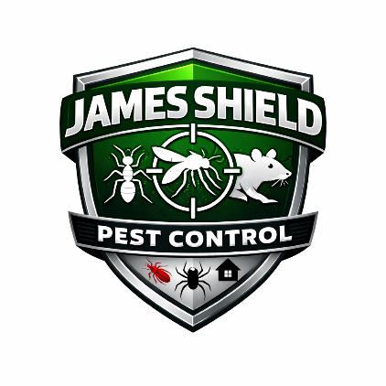
James Shield Pest Control
Paid Holiday Policy

1. Purpose
The purpose of this policy is to establish uniform guidelines regarding Company-observed holidays and eligibility for holiday pay. James Shield Pest Control recognizes designated holidays to provide employees with paid time off in observance of nationally recognized occasions.
Due to the nature of the pest control industry and the operational needs of our customers, certain employees may be required to work on designated holidays.

2. Scope
This policy applies to all eligible employees of James Shield Pest Control.

3. Company-Observed Holidays
James Shield Pest Control observes the following paid holidays each calendar year:
- New Year’s Day
- Memorial Day
- Juneteenth
- Independence Day
- Labor Day
- Veterans Day
- Thanksgiving Day
- Christmas Day
If a holiday falls on a Saturday, it may be observed on the preceding Friday.
If a holiday falls on a Sunday, it may be observed on the following Monday, subject to operational needs and management discretion.

4. Eligibility for Holiday Pay
Holiday pay is available to full-time employees in good standing.
To receive holiday pay, an employee must:
- Be actively employed on the holiday; and
- Work their scheduled workday immediately before and after the holiday, unless the absence is approved in advance.
Part-time, temporary, and contract employees are not eligible for paid holidays unless otherwise required by law.

5. Holiday Pay Compensation
Eligible employees will receive holiday pay at their regular base rate of pay for the number of hours they would normally be scheduled to work that day.
Holiday pay does not include:
- Overtime premiums
- Bonuses
- Commissions
- Incentives
- Shift differentials

6. Employees Required to Work on a Holiday
Due to the nature of Company operations, employees may be required to work on a recognized holiday.
Employees required to work on a holiday will receive:
- Holiday pay in accordance with applicable federal and state laws; and
- Additional compensation as required by law or Company policy.
If no additional premium is required by law, holiday work will be compensated at the employee’s regular rate unless otherwise approved by management.

7. Interaction with Other Leave
If a Company-observed holiday occurs during an employee’s approved Vacation or Paid Sick Leave:
- The day will be recorded as a holiday rather than charged against the employee’s Vacation balance, provided the employee is otherwise eligible for holiday pay.
Holidays that occur during unpaid leave (including FMLA) will not be paid unless required by law.

8. Separation of Employment
Holiday pay is not paid out upon separation of employment.
Employees must be actively employed on the holiday to receive holiday pay unless otherwise required by law.

9. Administration
James Shield Pest Control reserves the right to:
- Modify the list of observed holidays;
- Adjust holiday schedules based on business needs;
- Interpret and administer this policy in compliance with applicable laws.
This policy may be amended, modified, or terminated at the Company’s discretion.

